Rest Api explorer -> import set api

First we have to make user to give them credentials
we see the web_service_access_only is deprecated in the latest version
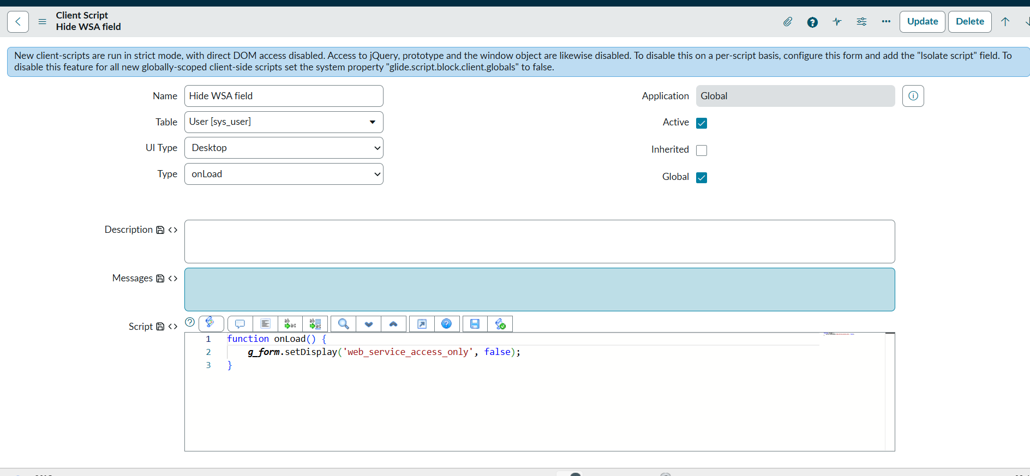
So we will use Internal Integration User
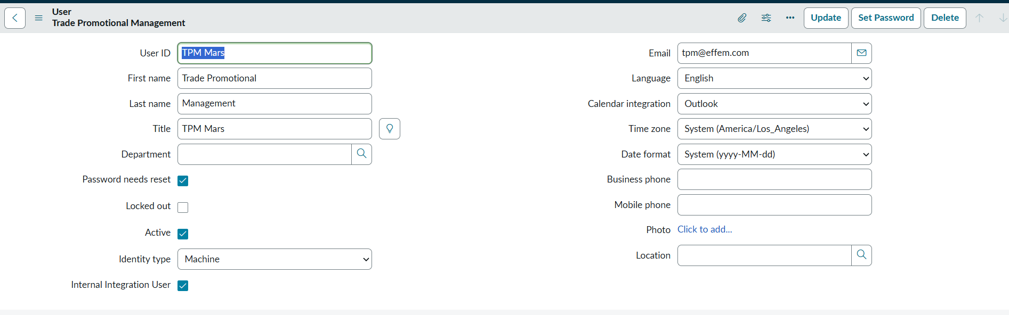

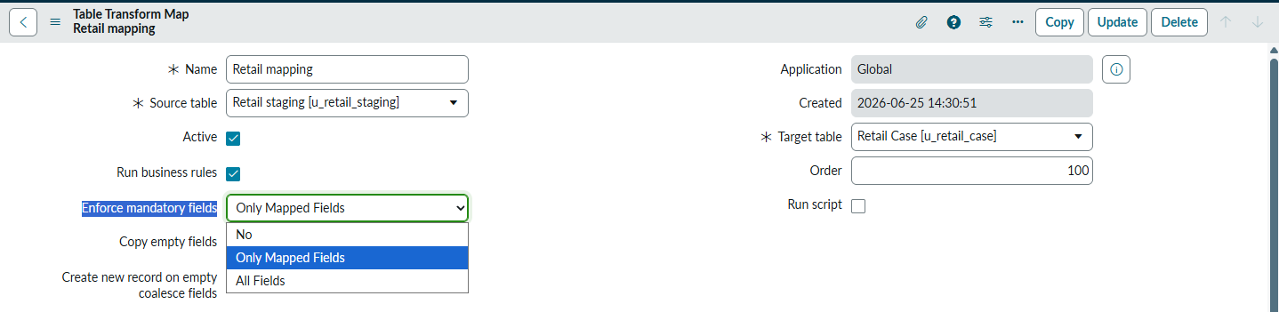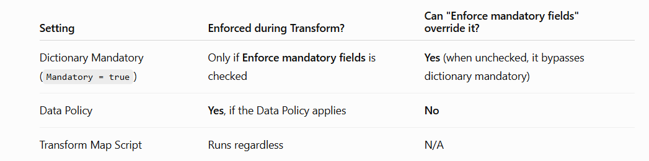
Option | Meaning | Example
No | Does not enforce mandatory fields during the transform. Records are imported even if mandatory fields are empty. | If Caller is mandatory on the target table but the import doesn't provide it, the record is still inserted (unless another rule blocks it).
All | Enforces all mandatory fields defined on the target table. If any mandatory field is missing, the record is rejected and an error is logged. | Target table has mandatory fields Number, Short Description, and Category. If Category is missing, the record is skipped.
Only mapped fields | Enforces mandatory validation only for mandatory fields that have a field map in the transform map. Mandatory fields that are not mapped are ignored. | Target table has mandatory fields Short Description and Category. You mapped only Short Description. If Short Description is empty, the record fails. If Category isn't mapped at all, the record is still imported.

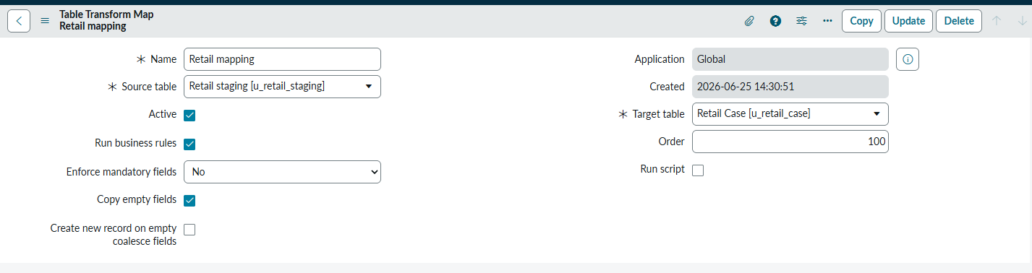
Copy Empty Fields:
It Copies the empty field as well from the staging table
Let make assignment group blank
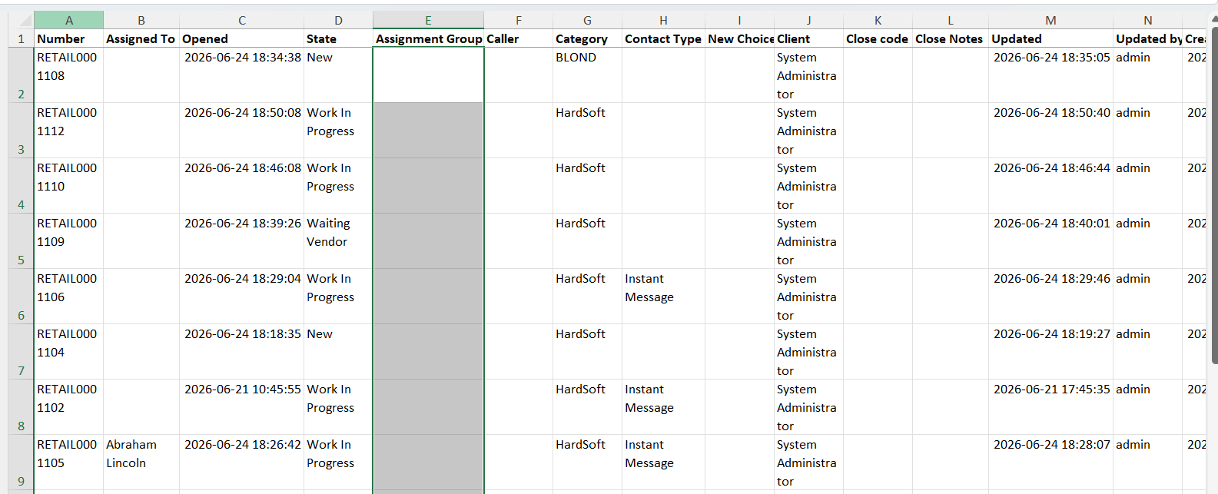

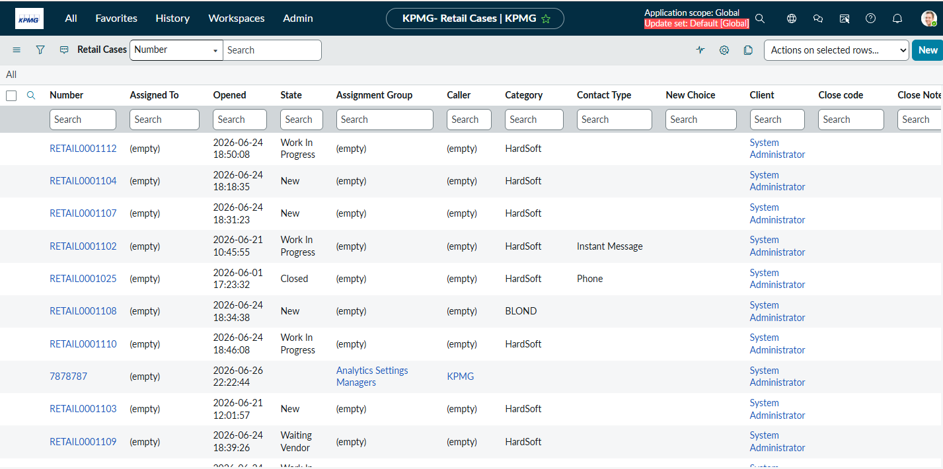



Create new record on empty coalesce field: false
Now we deleted all the number field in excel and loaded
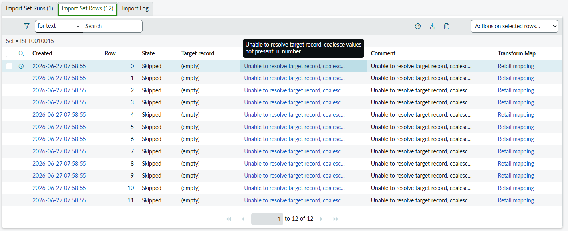

Create new record on empty coalesce field: true
Coalesce field we seleted was number , that is auto generate and right so here what will happen
Even when in excel the number is not there row will be inserted , since here setting with number was auto generate so this will generate the new value for number field itself
